1. Summarize chapters form 1.1. to 1.4 in the text book.

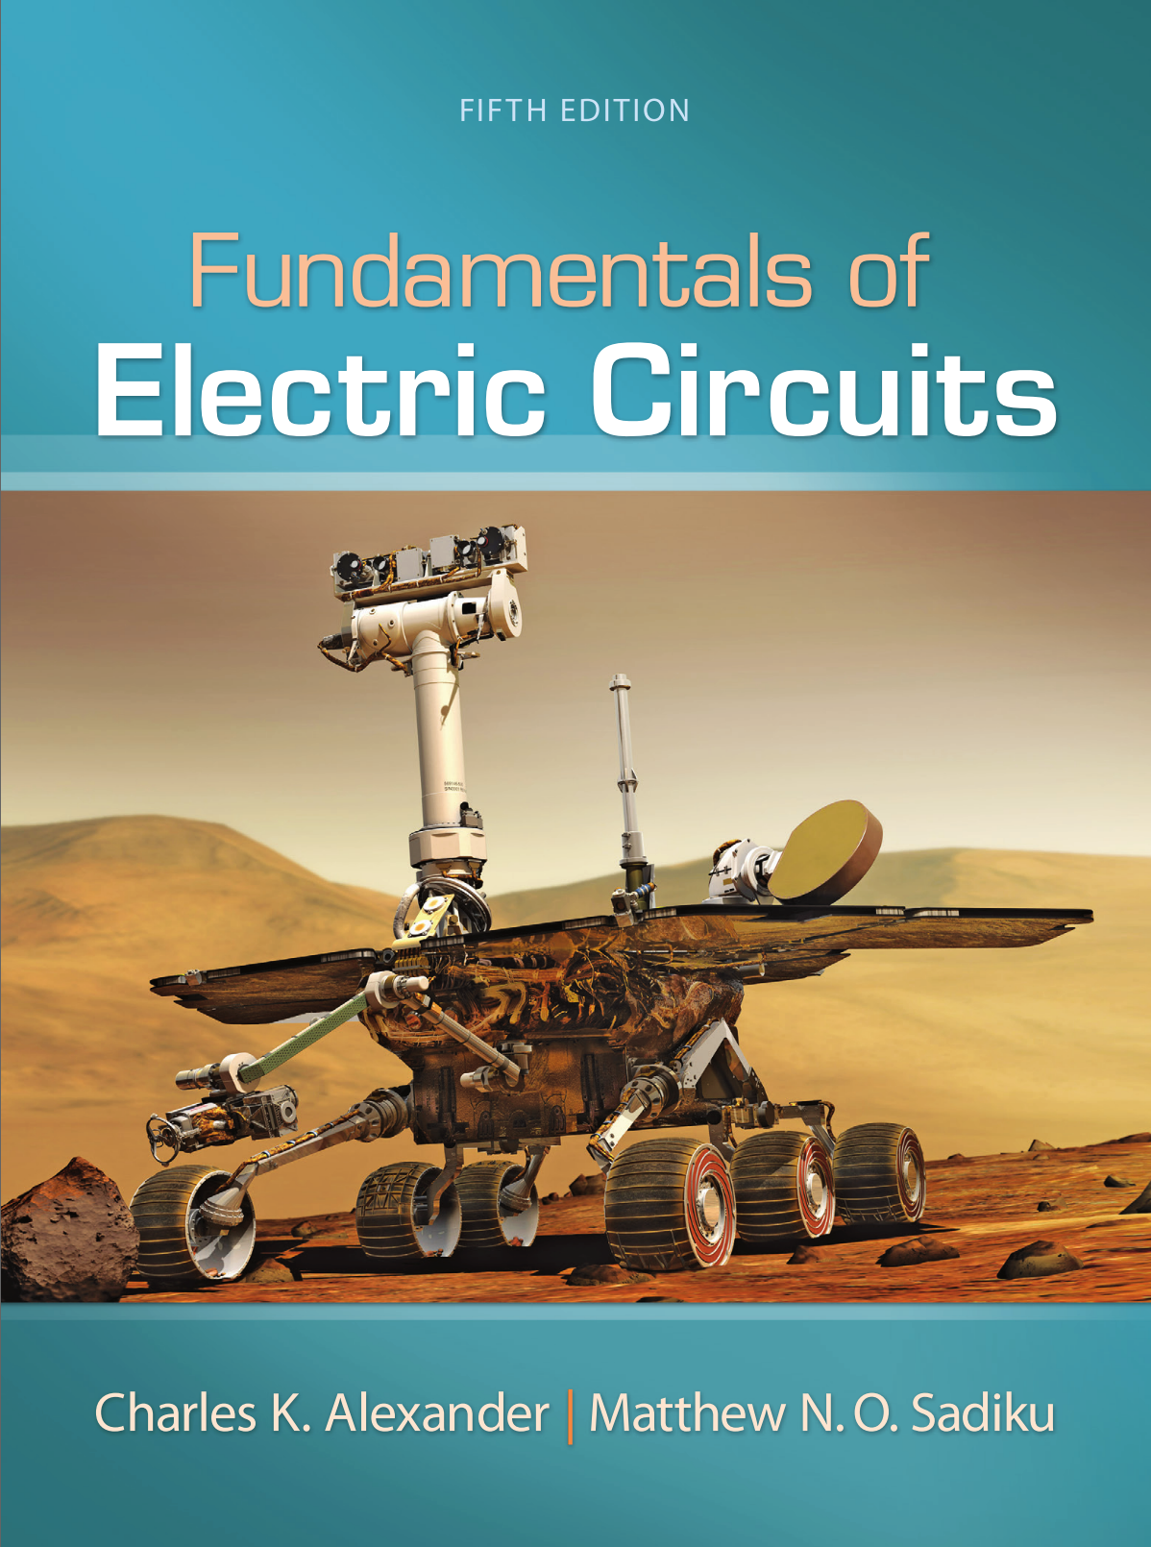

1. Please describe the solution of the examples and practice-problems in each chapter by handwriting. And take a picture of the solutions and attach the picture to the assignment file.